
IBM – CICS Integration Workshop

L34-A Simple OSGi Program with CICS Explorer

Lab Version V61.02.zVA

July 30, 2024

Please send any comments on this lab exercise to:
Steve Fowlkes, Eric Higgins, or Leigh Compton
fowlkes@us.ibm.com
eric.higgins@us.ibm.com
lcompton@us.ibm.com

Overview

This lab exercise illustrates a simple use case in CICS; using the CICS Explorer to develop a Hello World program coded in the Java programming language, deploy, and execute it in CICS TS for z/OS. This lab exercise illustrates a simple scenario—Java application program running in CICS TS using the JVMServer resource (which uses OSGi).

The OSGi support in CICS TS is required for application programs written in Java that will be running in a JVM server (i.e. non-Liberty). This is an overly simple Java program that illustrates the use of OSGi to package and manage Java applications in CICS.

We will test the OSGi Java program at a 3270 terminal. This was chosen for convenience; a Java program can be used any place that a COBOL application program can be invoked.

Lab Requirements
Please note that there are often several ways to perform functions in and for CICS. This lab exercise will present one of the ways. If you are familiar with CICS, you will notice that some of the statements are general, and not necessarily true for every situation.

This lab exercise assumes some knowledge of an Eclipse-based environment. You will also be using certain z/OS functions such as editing files, submitting jobs, and looking at job output. Additional some knowledge of CICS is preferred as we will be defining and installing CICS resources.

- Data files: This lab exercise assumes that you are using the VMware image that was prepared for this workshop and that the various artifacts discussed and used in this lab exercise are available in the VMware image.
- z/OS Access: Access to the class z/OS image is required, where some steps have been performed. It is assumed that you have been given a userid and password.

- CICS Explorer: This lab exercise assumes that you are using the latest CICS Explorer.

Lab Step Overview

Part 1: Start the CICS Explorer
This is a simple step the starts the CICS Explorer
Part 2: Java Development using the CICS Explorer
In this part of the lab exercise you will set the target environment (only once per development environment). You will create a Plug-in project and modify the deployment descriptor.

Part 3: Create a CICS Bundle Project
This part of the lab exercise will create a CICS Bundle project, which will contain the OSGi bundles from Part 2.

Part 4: Deploy the CICS Bundle to CICS TS
This part of the lab exercise will have you export the CICS Bundle project (and associated OSGi bundles) to z/OS and define a BUNDLE resource to CICS.

Part 5: Define CICS Resources
In this part of the lab exercise you will act as a CICS Systems Programmer and define the associated CICS resources. You will define and install a JVM Server, a BUNDLE, a PROGRAM, and a TRANSACTION.

Part 6: Test the Application
This part of the lab exercise lets you test the application on a 3270 device (again, the choice of a 3270 device was for simplicity, Java can be used as an application programming language most anywhere other application programming languages can be used).

Part 7: Summary
This is a recap of the steps performed in this lab exercise.

Part 1: Start the IBM Explorers

We have installed the CICS Explorer for you.

- From the desktop, double-click the IBM Explorer icon to start the IBM Explorer for zOS and CICS Explorer..

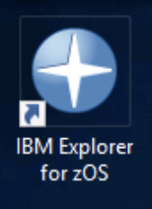

- If prompted, from the Select a workspace dialog, click the OK button.
- If the CICS Explorer shows you a Welcome page click the Workbench icon in the upper-right corner to go to the CICS Explorer. Then maximize the CICS Explorer window.

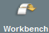

Verify that you have connections to the z/OS host system.

- Connections to the z/OS host system have been defined for you in the Host Connections view of the Remote System Explorer perspective. If either the CMCI and z/OS Remote System options are not green, highlight the option and click the Connect button. Both the Remote System Explorer and CMCI connections should be started and active.
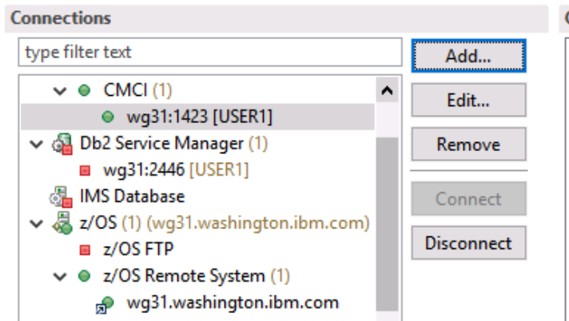

Part 2: Develop the Java Program
Set the Target Environment (once per development environment)

These steps add a ‘CICS TS V6.1’ OSGi target environment to your workspace. When creating a project with a target environment of CICS TS V6.1, the CICS Explorer (Eclipse) environment will add the necessary support to your project to develop Java programs for CICS TS V6.1. The ‘CICS TS V6.1’ environment needs to be added only once per workspace.
- From the CICS Explorer menu bar, select Window > Preferences. On the left, expand Plug-in Development and click Target Platform (takes a moment to load on first entry).
- From the Preferences dialog, the Target Platform pane (on the right), click the Add button.

- From the New Target Definition dialog, press the Template radio button, and from the Pull-down menu next to Template, select CICS TS V6.1 with Enterprise Java. Then click the Next button.

- From the Target Content editor dialog (after it is done checking), click the Finish button.

- Back on the Preferences dialog, the Target Platform pane, check the box next to CICS TS V6.1 with Enterprise Java to set it as the default target environment. Then click the Apply and Close button (click OK on the Target Version dialog).

- You may receive a warning stating “You have selected a target with a newer version that your current Eclipse installation. This can cause unexpected behaviour in PDE. Please use a newer version of Eclipse.” You can ignore this message by clicking the OK button.
Create a Plug-in Project
In this part of the lab exercise you will add a Java class to a Plug-in project. The Plug-in project corresponds to an OSGi bundle. This OSGi bundle will contain a Hello World program for the CICS environment.

- Switch to the Plug-in Development perspective.

- From the CICS Explorer menu bar, select File > New > Plug-in Project.
- From the Plug-in Project dialog, specify a Project name of com.ibm.cics.simple.sample, and in the Target Platform section, select an OSGi framework of standard, then click the Next button.
- On the Content page of the New Plug-in Project dialog, change the Version to 1.0.0 (remove the ‘.qualifier’ we will not use it).

- Still on the Content page, specify an Execution Environment of JavaSE-1.8.

- Still on the Content page of the New Plug-in Project dialog, uncheck the box next to Generate an activator, then click the Next button.
Note that we asked you to uncheck the box requesting an activator class be generated. We aren’t going to use this activator class, however activator classes can be used if some action needs to take place when the OSGi environment activates your bundle. There are some constraint around the use of Activator classes in a CICS environment (for example they cannot contain JCICS API), so be sure to view the CICS TS V5.6 documentation on Activator classes.

- From the Templates page of the New Plug-in Project, uncheck Create a plug-in using one of the templates and press the Finish button (a manifest editor will open).

- From the com.ibm.cics.simple.sample manifest editor, select the Dependencies tab (across the bottom of the editor) and to the right of Imported Packages, click the Add button.

- Select com.ibm.cics.server and click Add (this allows your program to access the JCICS classes).

- Still in the manifest editor, click on the MANIFEST.MF tab, and in the manifest, add the following line into the editor (after Bundle-Version).
CICS-MainClass: com.ibm.cics.simple.sample.HelloCICSWorld

- Save and close the manifest editor.
- In your com.ibm.cics.simple.sample project, right-click on src > New > Package and add a Package with a name of com.ibm.cics.simple.sample. Click the Finish button.
- From the Project Explorer view, right-click on your package and add a New > Class named HelloCICSWorld. Click the Finish button.

- Replace the contents with the following:
package com.ibm.cics.simple.sample;
import com.ibm.cics.server.CommAreaHolder;
import com.ibm.cics.server.Task;
public class HelloCICSWorld {
public static void main(CommAreaHolder CAH) {
Task t = Task.getTask();
if ( t == null )
System.err.println
("HelloCICSWorld example: Can’t get Task");
else
t.out.println("Hello from a Java CICS application");
}
}

- Note that there should be no error messages. If there are any errors, contact a lab instructor.

- Save and close your HelloCICSWorld.java editor.
Note: we are relying on the default behavior of Eclipse to compile our program when we save the file. If you turn off the default behavior, you have to specifically ask for your program to be compiled. Most IDEs have the default set to compile your program when you save (so you are never told to compile your program, only to save your program). The program is compiled into a .class file. Although the .class file is not visible (by default) in the Project Explorer view, if you displayed the files in your project from Windows, you can see the .class file. Also, you can change the Eclipse default and have it display your .class file (but very very few people do that).

- Collapse your com.ibm.cics.simple.sample project.

Part 3: Create a CICS Bundle Project

In this part of the lab exercise, you will create a CICS Bundle project on your workstation, you will add the OSGi bundle (plug-in project) to the CICS Bundle. In the next part of the lab, you will then export the CICS Bundle from your workstation to Unix System Services (z/OS), then define and install a CICS BUNDLE definition in CICS that points to the CICS Bundle on Unix System Services.

A CICS Bundle project contains a cics.xml manifest file and one or more XML resource files. We will use wizards to add information about your OSGi bundles to the CICS BUNDLE project.

- From the CICS Explorer, the CICS Explorer menu bar, select File > New > Project.

- From the New project dialog, select CICS Resources > CICS Bundle Project and click the Next button.

- From the CICS Bundle Project dialog, provide a Project name of
com.ibm.cics.simple.sampleBUNDLE, and click the Finish button.
NOTE that your CICS BUNDLE manifest is opened in a manifest editor.

Add the OSGi bundle to your CICS BUNDLE Project

- From the CICS manifest editor, in the Defined Resources section, click the New button.

- From the drop-down menu, select OSGi Bundle Project Include.

- In the OSGi Bundle Project Include dialog, select the com.ibm.cics.simple.sample project, enter a JVM Server name of JVMSRV01, and click the Finish button.

Add a Transaction Definition to your CICS BUNDLE Project

- From the CICS manifest editor, in the Defined Resources section, click the New button.

- From the drop-down menu, select Transaction Definition and supply the following values:

Attribute | Value
Name | HELO
Description | Hello World Java Transaction
Program Name | HELOWRL1

- Remove the check from Open Editor, then click Finish to complete the steps to add the Transaction Definition.

Add a Program Definition to your CICS BUNDLE Project

- From the CICS manifest editor, in the Defined Resources section, click the New button.

- From the drop-down menu, select Program Definition and supply the following values:

Attribute | Value
Name | HELOWRL1
Description | Hello World Java Program
Program Type | check the Java radio button
Service Name | com.ibm.cics.simple.sample.HelloCICSWorld
JVMServer | JVMSRV01

- Complete the steps to add the Program Definition.

- Close the Manifest Editor.

Part 4: Deploy the Bundle to z/OS

In this part of the lab exercise you will export your CICS BUNDLE to the z/OS UNIX System Service File System. When you export your CICS BUNDLE, all of the OSGi bundles referenced by your CICS BUNDLE will also be exported.

You will then create a BUNDLE resource definition in CICS that will reference the bundle directory on zFS. When the BUNDLE resource is installed, the OSGi bundles and the code they contain will be installed into the indicated JVM server.

To copy the CICS Bundle information and the associated OSGi bundles to z/OS, we will use the ‘Export Bundle Project to z/OS UNIX File System’. We will then create a BUNDLE resource in CICS using the CICS Explorer.

Export the CICS Bundle Project

- From the CICS Explorer, the Plug-in Development perspective, Project Explorer view, right-click on the com.ibm.cics.simple.sampleBUNDLE CICS bundle project and from the context menu, select Export Bundle Project to z/OS UNIX File System.

- From the Export Bundle pop-up, click the Export to a specific location in the file system and click the Next button.

- If you have a connection, but not signed on, select the drop-down to the right of Connection and choose your z/OS Connection to sign on.

- From the Export Bundle dialog enter the information below, then press the Finish button.

Note: If you are redeploying your Bundle, check the box for Clear existing contents of Bundle directory.
Field | Value
Bundle project: | com.ibm.cics.simple.sampleBUNDLE
Parent Directory: | /u/user1/cicslab/bundles
Bundle Directory: | /u/user1/cicslab/bundles/com.ibm.cics.simple.sampleBUNDLE_1.0.0
Clear existing contents of Bundle directory | Checked

Caution: be sure the parent directory and bundle directory start with your home directory (/u/user1).

Part 5: Define Resources to CICS

This section defines resources to CICS.

Define and Install a JVMServer

A JVMServer is needed to run your Java programs. You may already have a JVM server with a name of JVMSRV01. If you don’t already have a JVM server named JVMSRV01, you will need to define and install one as follows.

- Switch to the Remote Systems Explorer perspective, the Remote Systems view. Right-click on Local > Local Files > Drives > C:\CICSLAB\Java\ JVMProfiles\DDWOSGI and select copy from the popup menu.

- From the CICS Explorer, the Remote System Explorer perspective, the Remote Systems view, right-click on MyzOS > z/OS UNIX Files > My Home > cicslab > JVMProfiles and from the context menu select Paste.

NOTE: The JVMProfile needs to be DDWOSGI.jvmprofile, not DDWOSGI. The .jvmprofile extension is a required.

- Right-click on DDWOSGI (the file you just pasted in) and select Rename from the popup dialog. Enter a New name of DDWOSGI.jvmprofile and click OK.

- Double-click on DDWOSGI.jvmprofile to open it in the editor. Ensure that it looks okay (otherwise contact a lab instructor). Close DDWOSGI.jvmprofile.

- Switch to the CICS SM perspective and define a JVM server resource definition to run the Java programs. Define a JVMserver with the following attributes.
Attribute | Value
Group | WORKSHOP
JVMServer | JVMSRV01
Jvmprofile | DDWOSGI

- From the JVMSRV01 (JVM Server Definition) view, use the drop-down menu to Install your JVMserver

- From the Perform INSTALL Operation dialog, click the OK button. If the installation of your JVM server resource was not successful, contact a lab instructor.

Define and Install the CICS BUNDLE resource definition

- From the CICS SM perspective, select Definitions > Bundle Definitions.

- From the Bundle Definitions view, right-click in an open area and from the context menu, select New.

- From the Create Bundle Definition dialog, specify the following, then click the Finish button.
Attribute | Value
Resource/CSD Group | WORKSHOP
Name | OSGIBUN1
Description | CICS Bundle for Simple Java Program
BUndledir | /u/user1/cicslab/bundles/com.ibm.cics.simple.sampleBUNDLE_1.0.0/  Note: Use the Browse button to select your Bundle

- From the OSGIBUN1 (Bundle Definition), use the drop-down menu to Install your OSGIBUN1 bundle definition.

- From the Perform INSTALL Operation dialog, click the OK button. If the installation of your BUNDLE resource was not successful, contact a lab instructor.

- Close your OSGIBUN1 (Bundle Definition) view.

View the OSGi Bundles in your CICS region

- From the CICS SM perspective, from the menu bar, select Operations > Java > OSGi Bundles. Verify that your OSGi bundle exist, has been installed properly, and is in the ACTIVE state. If you don’t see your OSGi bundle or if it is not all in the ACTIVE state, contact a lab instructor.

View the OSGi Service in your CICS region

- From the CICS SM perspective, from the menu bar, select Operations > Java > OSGi Services. Verify that you have an OSGi services named com.ibm.cics.simple.sample.HelloCICSWorld, and that it is in the ACTIVE state. If you don’t see your OSGi service or it is not ACTIVE, contact a lab instructor.
- You refer to these services when you define PROGRAM definitions. You added the program definition to the CICS BUNDLE, so it was dynamically defined for you. You can select Operations > Programs to see your HELOWRL1 program. Set a Quick Filter if you like (right-click a program name and select Add Quick Filter).

Part 6: Test the Application Program

We are done installing the application so the next step is to verify that all of our application artifacts are in the right place and that all of our CICS definitions are correct. We will be using a 3270 device to test your work.

- Start a 3270 session with your CICS region (from the VTAM MSG 10, enter
CICS and press enter. Then clear your screen).

- Type in a tranid of HELO.

- Your terminal should look as follows…
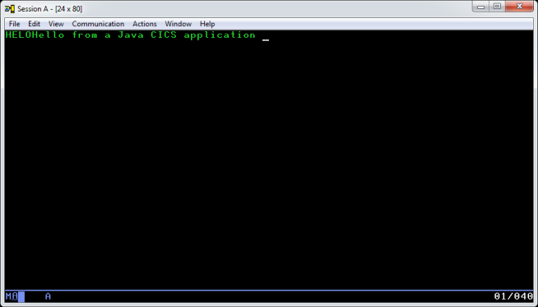

- If you have any question, contact a lab instructor.

Part 7: Summary

Congratulations, you have just built a CICS Java application using the OSGi support in CICS.

In this lab you:
- Started the CICS Explorer.
- You wrote a simple HelloWorld program that uses some of the CICS API (you copied it)
- You packaged Java code as an OSGi bundle in a CICS BUNDLE, along with CICS resource definitions (a Program and a Transaction)
- You deployed the CICS BUNDLE into CICS
- You defined a JVMServer definition (a JVM) for the application
- You tested your application

If you have any questions about anything you did in this lab exercise, please contact one of the lab instructors.

